**Test Case**

The test case is defined as a group of conditions under which a tester determines whether a software application is working as per the customer's requirements or not. Test case designing includes preconditions, case name, input conditions, and expected result. A test case is a first level action and derived from test scenarios.

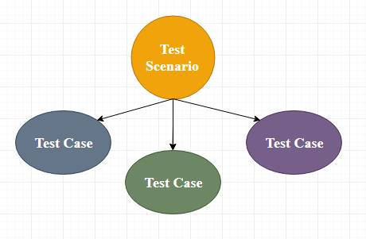

It is an in-details document that contains all possible inputs (positive as well as negative) and the navigation steps, which are used for the test execution process. Writing of test cases is a one-time attempt that can be used in the future at the time of regression testing.

Test case gives detailed information about testing strategy, testing process, preconditions, and expected output. These are executed during the testing process to check whether the software application is performing the task for that it was developed or not.

Test case helps the tester in defect reporting by linking defect with test case ID. Detailed test case documentation works as a full proof guard for the testing team because if developer missed something, then it can be caught during execution of these full-proof test cases.

**Test Scenario:**

A **Test Scenario** is defined as any functionality that can be tested. It is also called *Test Condition* or *Test Possibility*. As a tester, you should put yourself in the end user’s shoes and figure out the real-world scenarios and use cases of the Application Under Test.

**Scenario Testing**

**Scenario Testing** in software testing is a method in which actual scenarios are used for testing the software application instead of test cases. The purpose of scenario testing is to test end to end scenarios for a specific complex problem of the software. Scenarios help in an easier way to test and evaluate end to end complicated problems.

**How to Write Test Scenarios**

As a tester, you can follow these five steps to create Test Scenarios-

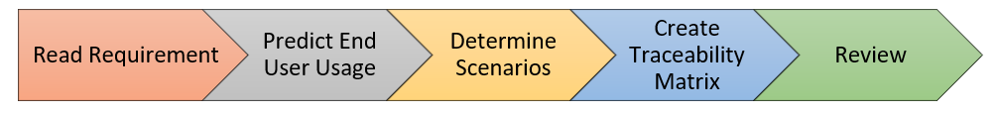

* **Step 1**: Read the Requirement Documents like BRS, SRS, FRS, of the System Under Test (SUT).  You could also refer uses cases, books, manuals, etc. of the application to be tested.
* **Step 2**: For each requirement, figure out possible users actions and objectives. Determine the technical aspects of the requirement. Ascertain possible scenarios of system abuse and evaluate users with hacker’s mindset.
* **Step 3:** After reading the Requirements Document and doing your due Analysis, list out different test scenarios that verify each feature of the software.
* **Step 4:** Once you have listed all possible Test Scenarios, a[Traceability Matrix](https://www.guru99.com/traceability-matrix.html)is created to verify that each & every requirement has a corresponding Test Scenario
* **Step 5:**The scenarios created are reviewed by your supervisor. Later, they are also reviewed by other Stakeholders in the project.

**Test Basis:**

Test basis is defined as the source of information or the document that is needed to write test cases and also for test analysis.

Test basis should be well defined and adequately structured so that one can easily identify test conditions from which test cases can be derived.

**Test Suite:**

Test suite is a container that has a set of tests which helps testers in executing and reporting the test execution status. It can take any of the three states namely Active, Inprogress and completed.

A Test case can be added to multiple test suites and test plans. After creating a test plan, test suites are created which in turn can have any number of tests.

Test suites are created based on the cycle or based on the scope. It can contain any type of tests, viz - functional or Non-Functional.